**Weblogic DataSource Configuration**

Step1: Open the Oracle WebLogic Server Administration Console and log in.

Step2 : Select Data Sources in the services section, and click New.

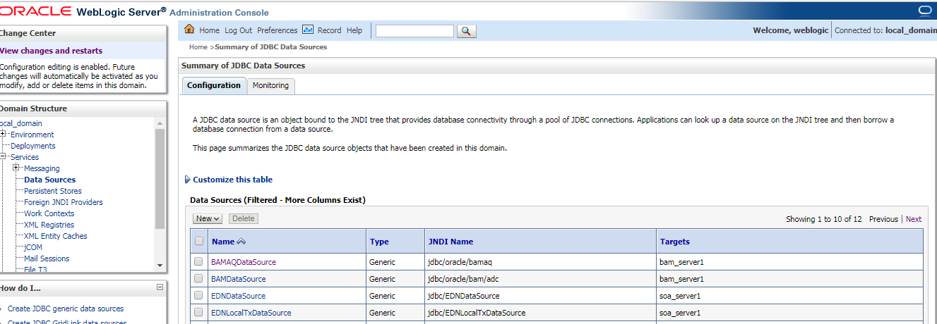

Step 3: Configure the data source as follows :

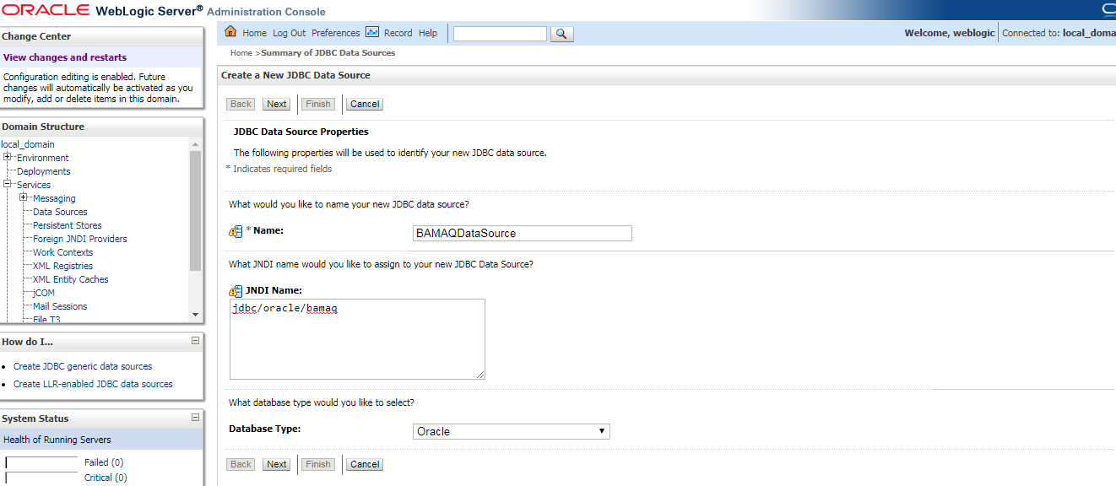

Step 4 : Give the jdbc datasource properties as above and click on next and Select Oracle's Driver (Thin) in the Database Driver field.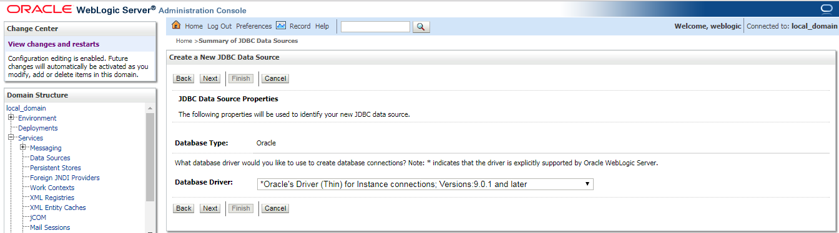

**Step 5:** Uncheck Support Global Transaction, and click Next.

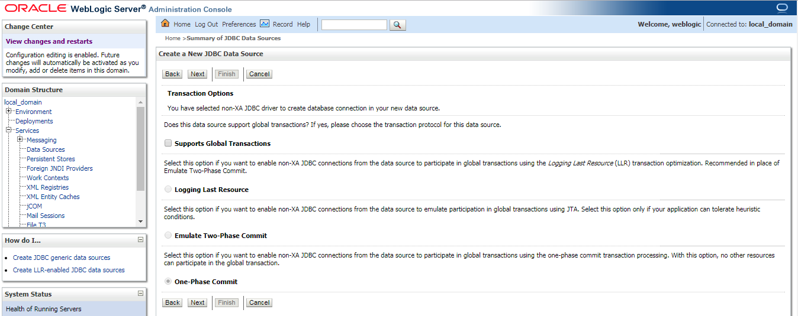

Step 6: Enter database details and click on next

Note : UserName must match with the Name given while creating domain related to BAM (RCU Schema)

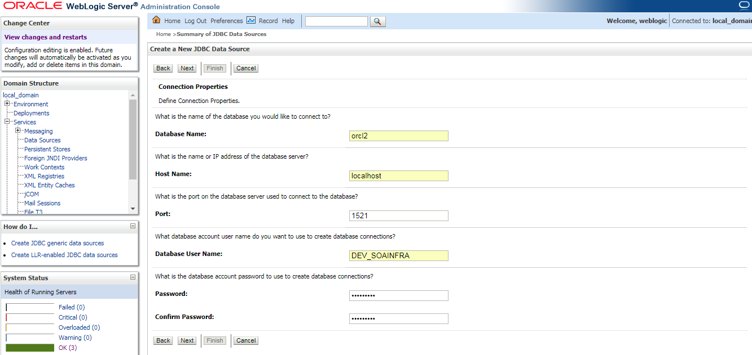

Step 7: click on the test configuration button we will get message as connection test succeeded

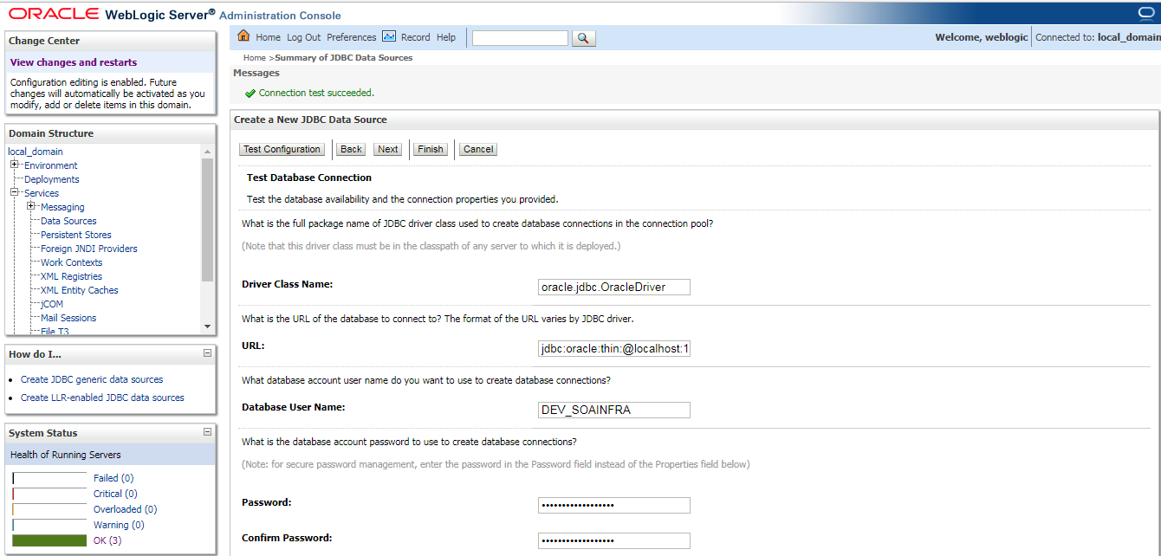

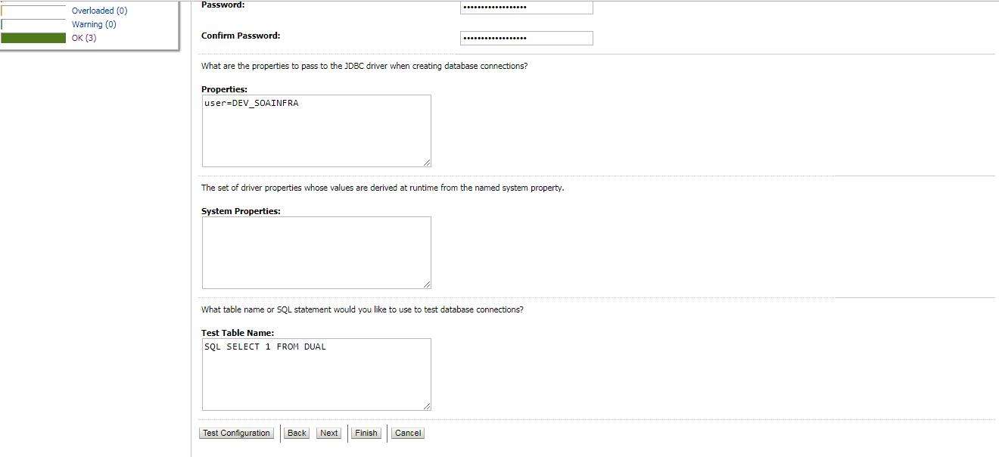

Step 8: Select the server where Oracle BAM is deployed, and click Finish.

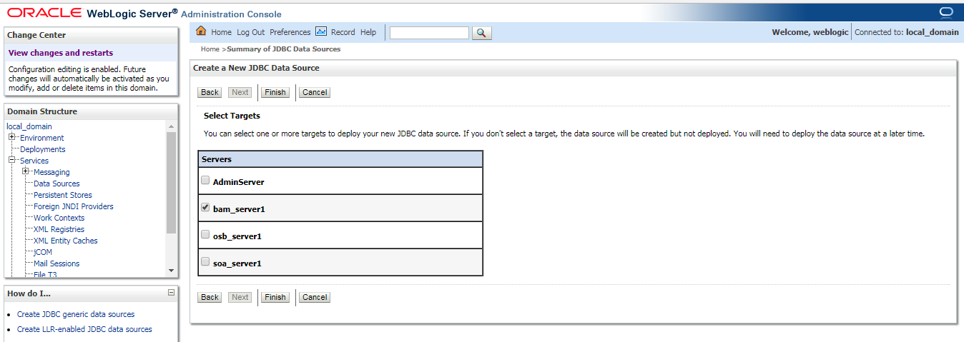

**Weblogic Foreign JMS server Configuration**

Step1 : In Oracle WebLogic Server Administration Console, on the Home page navigate to the JMS Modules page. (Services🡪Messaging🡪JMS Modules) and click on new

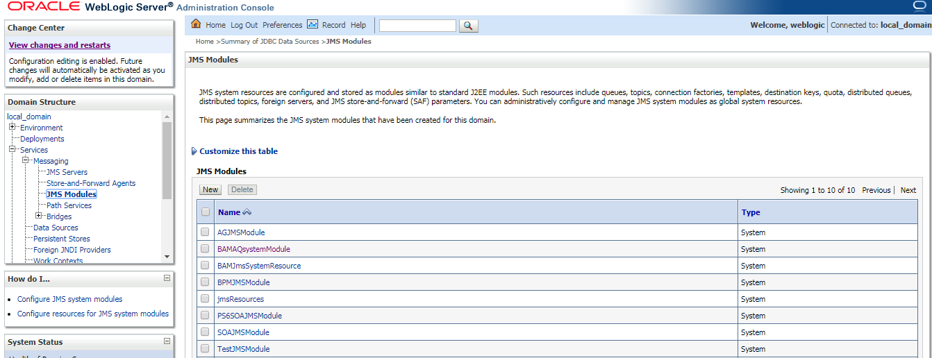

Step 2: Enter a name for the JMS module and click Next

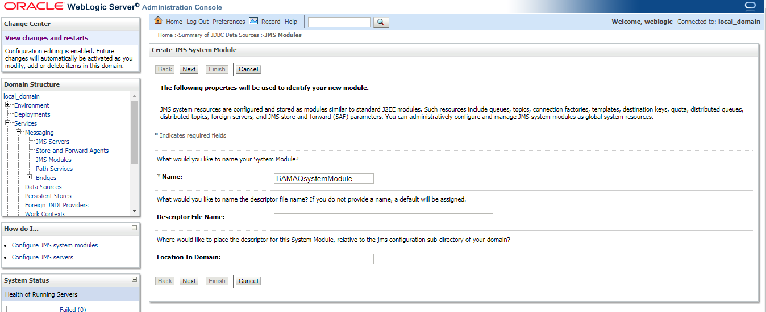

Step 3: Assign the target as the server where Oracle BAM is deployed, click Next, and click Finish.

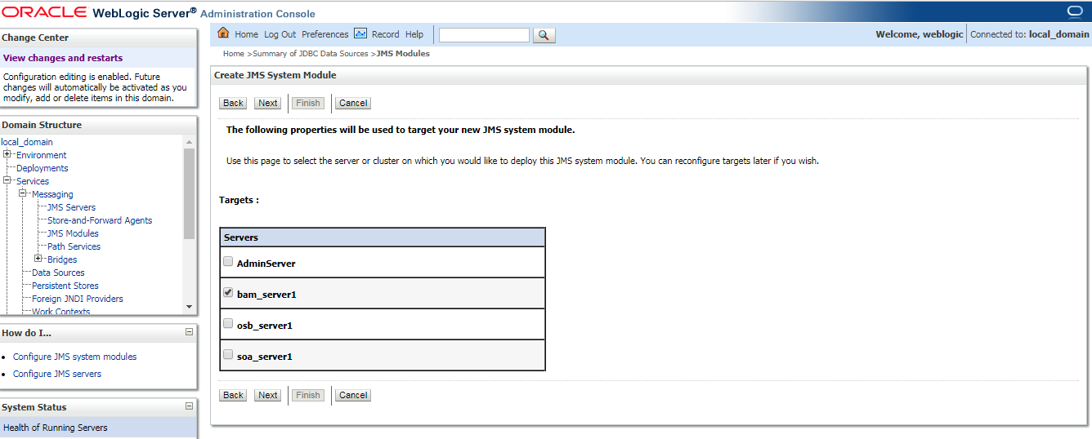

Step 4: create a Subdeployment.

[Home](http://localhost:7001/console/console.portal?_nfpb=true&_pageLabel=HomePage1) > >[JMS Modules](http://localhost:7001/console/console.portal?_nfpb=true&_pageLabel=JmsModulesTablePage) >[BAMAQsystemModule](http://localhost:7001/console/console.portal?_nfpb=true&_pageLabel=JMSSystemModuleConfigGeneralPage&handle=com.bea.console.handles.JMXHandle%28%22com.bea%3AName%3DBAMAQsystemModule%2CType%3DJMSSystemResource%22%29) >SubDeployments

And click on new

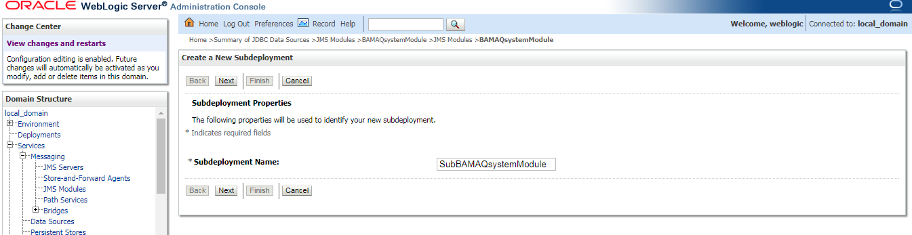

Target the Subdeployment to the JMS Server by selecting it from the list and click on finish

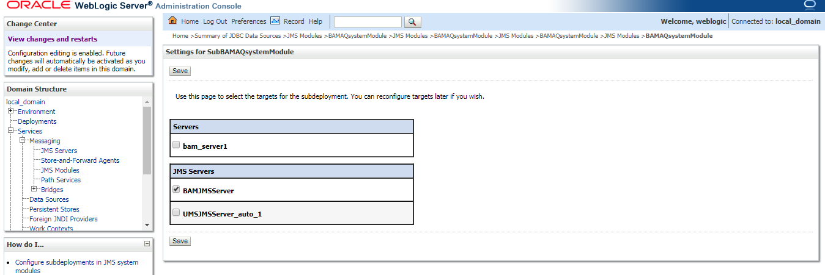

End of repetitive links 

Step 4: Add an Foreign Server to the JMS module.

Select the JMS module that was previously created, Click New, and go to the list of JMS resources. Select the Foreign Server option, and click Next.

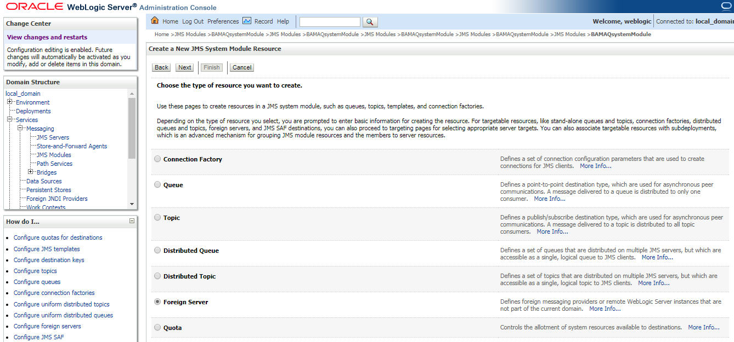

Enter a Name for the Foreign Server and click finish

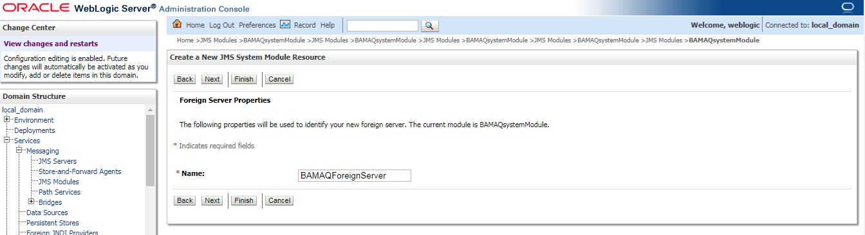

Step 5: Configure the Foreign Server.

Select the Foreign Server that was previously created.

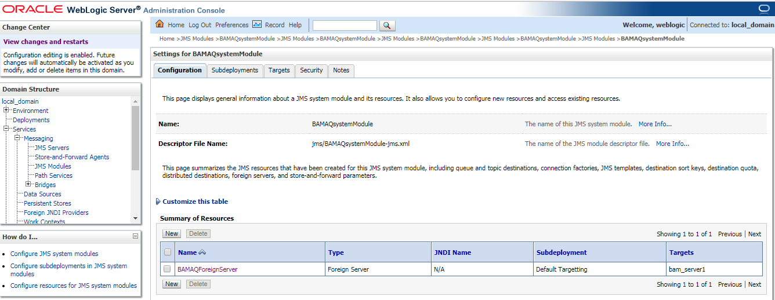

Enter **oracle.jms.AQjmsInitialContextFactory** in the JNDI Initial Context Factory field and **jdbc/oracle/bamaq** in the JNDI Properties field

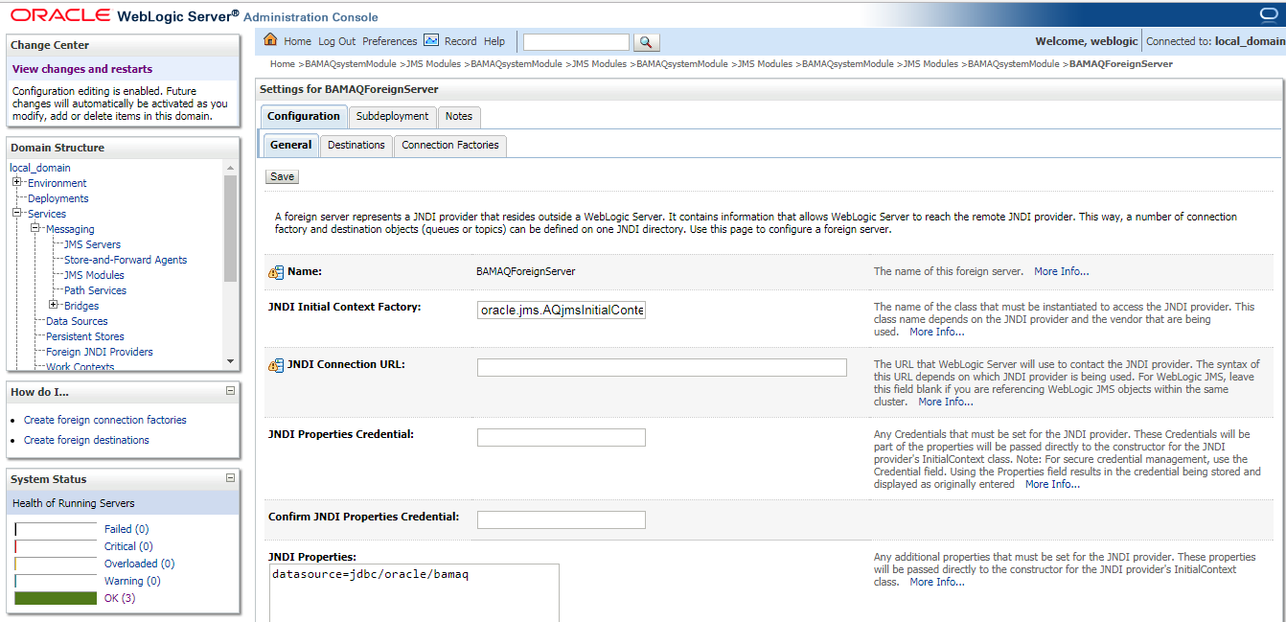

Check the Default Targeting Enabled checkbox and click on save.

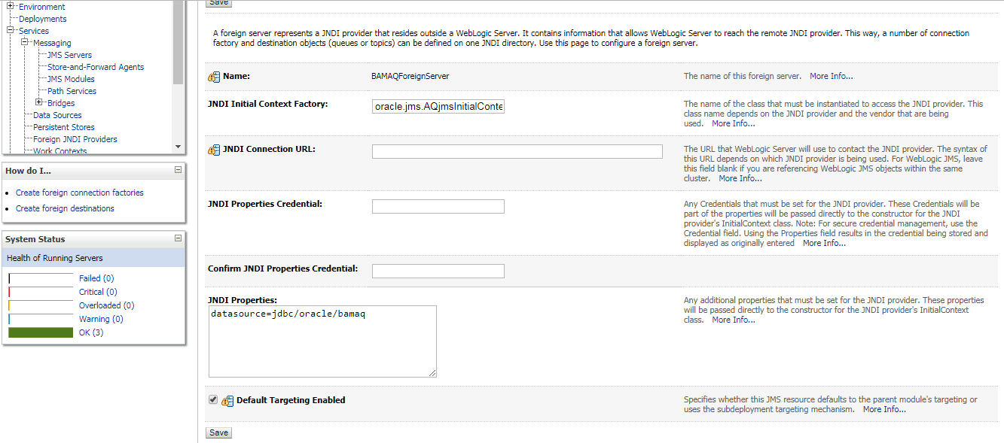

Step 6 : Add Connection Factories to the Foreign Server.

Select the Foreign Server that was previously created. Select the Connection Factories tab.

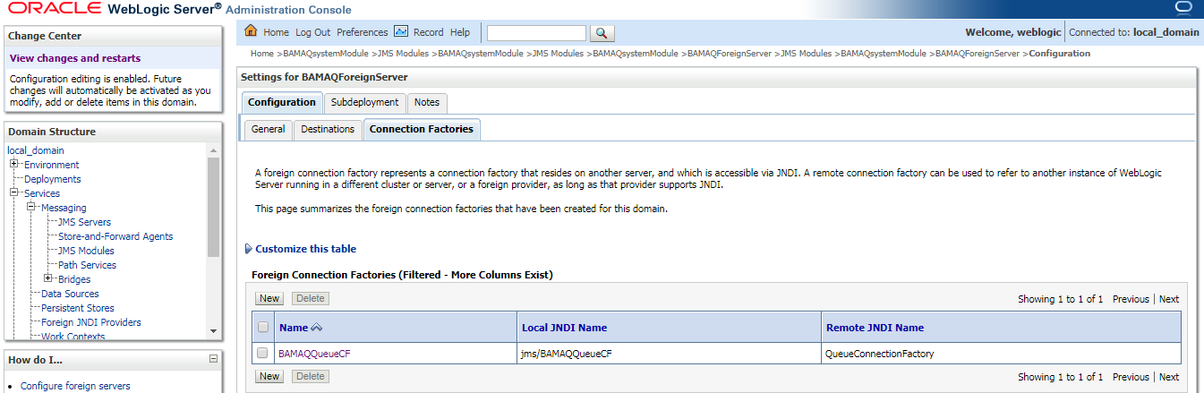

Click on new and enter a name and JNDI name for the connection factory and click on OK

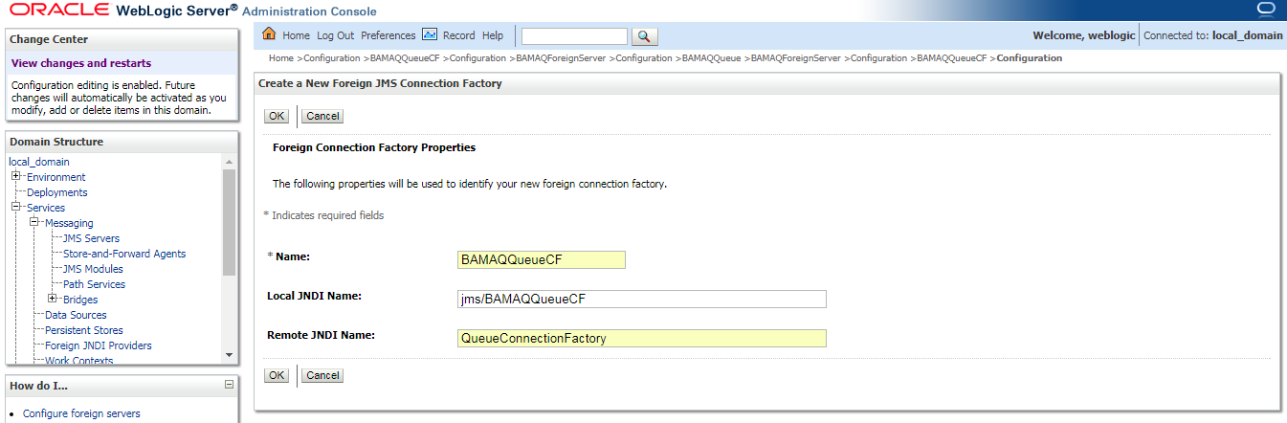

Step 7: Add Destinations to the Foreign Server.

Select the Foreign Server that was previously created and Select the Destinations tab and click on new

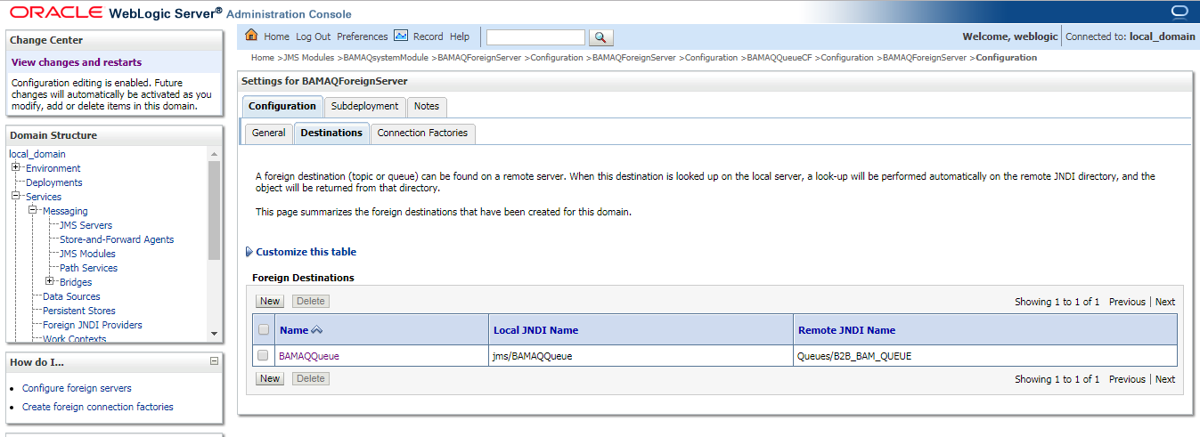

Enter a name, local and remote JNDI name for the destination and click on ok

Note: In the Remote JNDI Name field, enter Queues/queue_name if the destination is a queue, or enter Topics/topic_name if the destination is a topic.

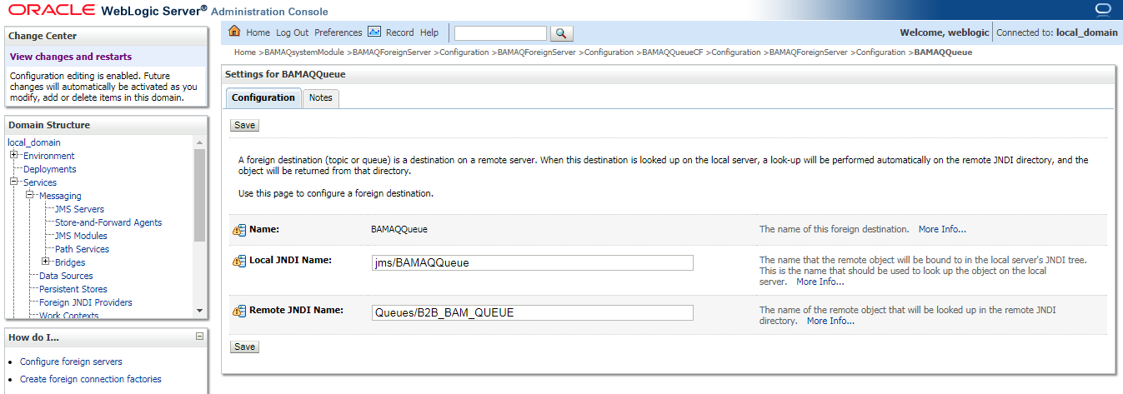

Step 8: Bounce the Weblogic server.